**Python Analysis:**

**Performed EDA on Fitness dataset_ STRAVA**

Used pandas, matplotlib, seaborn for visualization.

Analysed heart rate, sleep , steps, and weight trends.

**Fitness Data Analysis Report Summary**

Project Title:

**Fitness Data Analysis Based on Strava- Using Python**

**Objective:**

To conduct an in-depth exploratory data analysis (EDA) of fitness tracker data (such as heart rate, steps, calories, sleep, etc.) with Python to pick out trends, user patterns of behaviour and health observations mirroring app functionality of STRAVA

**Datasets Analysed:**

heartrate_seconds_merged.csv, minuteStepsWide.csv, sleepDay.csv, weightLogInfo.csv, hourly Intensities.csv , hourlySteps.csv, dailyActivity.csv etc

Key Analysis Done:

**1. Heart Rate Analysis**

Imported and visualized continuous heart rate data, cleaned and Identified daily peak ,average heart rate patterns. Compared heart rate intensity during active vs sedentary times.

**2. Steps & Activity Tracking**

Analysed step count distribution hourly, daily, and per user. Identified inactive users, most active hours, and intensity levels. Converted wide-format minute data into useful trends.

**3. Sleep Patterns**

Analysed total sleep time and time in bed. Highlighted short and disturbed sleep patterns.

Merged with activity data to explore how steps relate to sleep.

**4. Weight Tracking**

Examined weight entries and BMI. Correlated weight loss with step count or activity intensity.

**5. Duplicates & Cleaning**

Identified and removed duplicate entries using SQL and pandas. Cleaned inconsistent or null data across datasets.

**Visualizations Used:**

Bar charts, histograms, heatmaps, line plots.

Matplotlib & Seaborn used for styling and clarity.

Few of the graphs including below

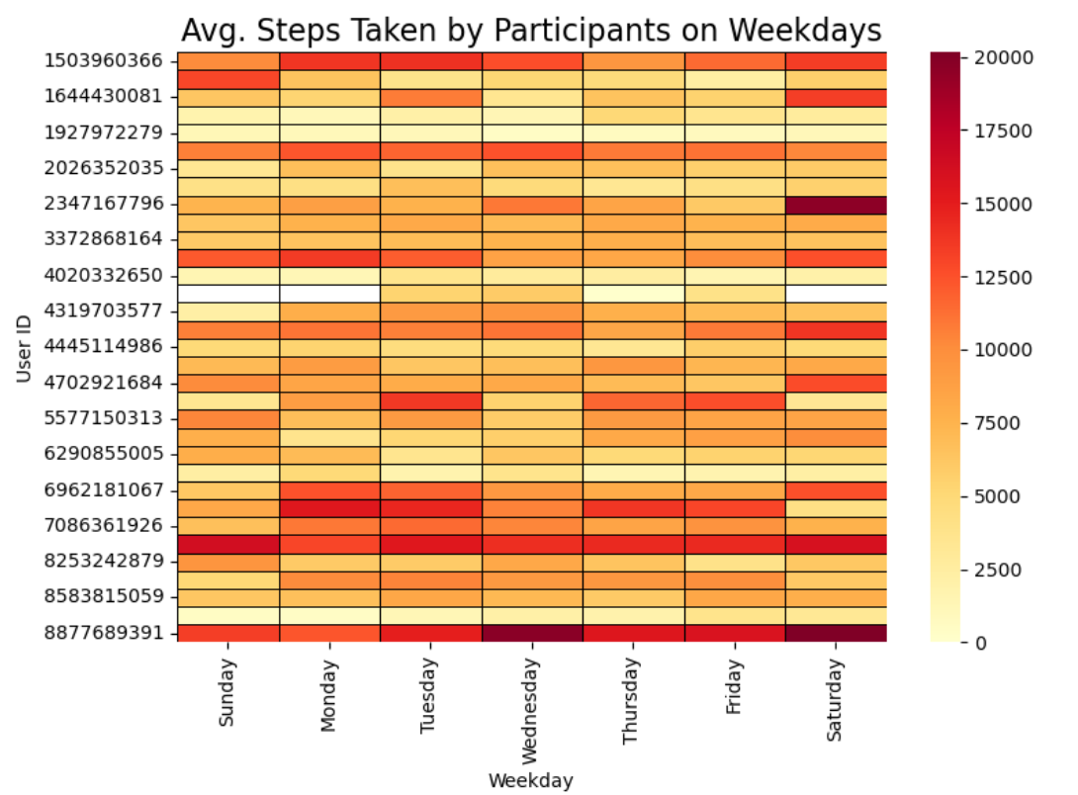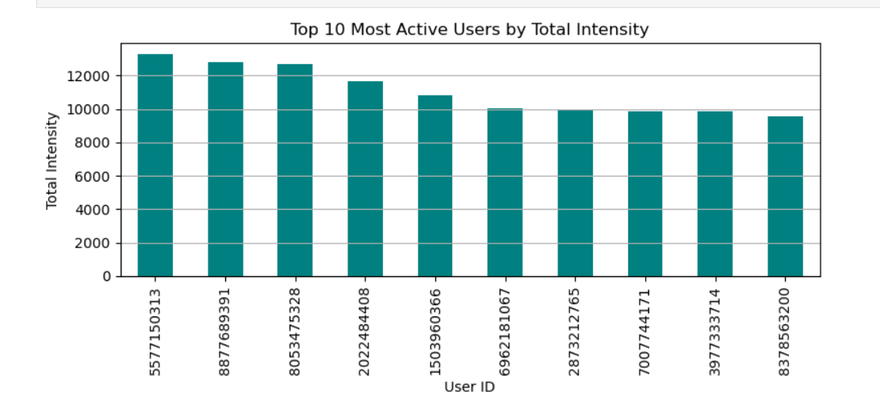

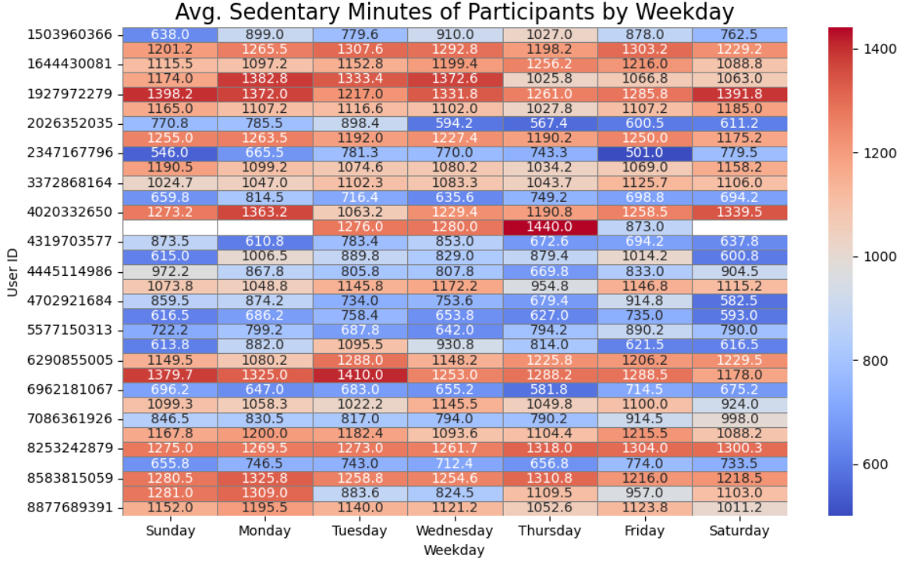

Insights:

Activity Insights: Most active hours are in the morning and early evening.

Sedentary minutes dominate over active minutes in most users.

Users with consistent step counts also show better sleep patterns.

Sleep Insights: Average sleep duration is below recommended levels.

Many users spend significant time in bed without sleeping effectively.

Weight & Heart Rate: Limited users log weight, but those who do show active behaviour.

High-intensity users generally show more consistent heart rate peaks.

User Engagement: Data reveals inconsistent tracking; suggests feature like daily reminders or reward badges (like STRAVA challenges) could boost activity.

Reminders can suggest to encourage users to regularly log weight and sleep for accurate analysis.

Identify users with consistently low activity or poor sleep for nudging them with health tips.